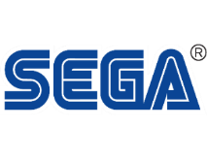
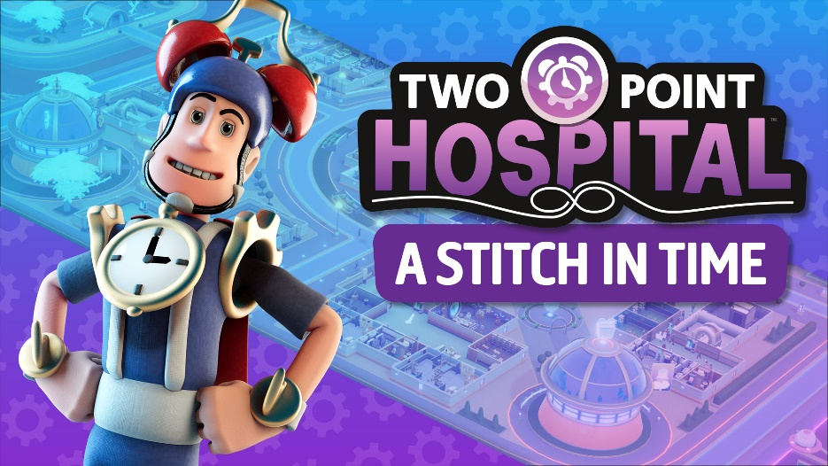

TRAVEL THROUGH SPACE & TIME IN NEW TWO POINT HOSPITAL DLC OUT NOW ON STEAM!

A Stitch in Time takes players on their greatest adventure yet!

London, England – 23 February 2021 – Join SEGA® Europe Ltd. and Two Point Studios™ Ltd. on a new and exciting journey through space and time with Two Point Hospital™: A Stitch in Time, available right now via Steam. Not sure yet? Captain Yesterday – inventor, entrepreneur, and fulltime charlatan – might convince you with his latest invention ‘The Yesterizer’ which he says is 100% safe for quick and carefree time travelling. “No catch, no consequences, no questions asked.” Will you risk it? Click here.

Two Point Hospital: A Stitch in Time offers players a fourth dimension of simulation gameplay, with new challenges and even more unusual illnesses. Step into The Yesterizer and visit three new locations set in medieval, pre-historic and futuristic time periods, while curing 34 anachronistic ailments, such as Jester Infection, Bone Head and Reptile Dysfunction. Decorate your hospitals with items from across the ages, like the much-desired Wormhole Bin or the Map of Time, which might come in handy…or not.

A Stitch in Time opens by taking players to the medieval town of Clockwise, plagued by ruptures in space and time, where patients have started (dis)appearing out of mysterious holes in the ground. Could those holes be portals to past? In the second level, the search for the missing patients leads to a forgotten age, to the dawn of all civilization, the pre-historic era. Awkwardly, there aren’t any time portals in this era to send patients back to the future. The final level brings players to a futuristic city, built high above the uninhabitable earth below. The Future is now overflowing with patients from all different time periods. Maybe Captain Yesterday can help send them home, preferably in one piece.

Two Point Hospital: A Stitch in Time is available on Steam right now for £6.99 , including a 10% early adopter discount between 23rd February – 2nd March 2021. For more information on Two Point Hospital on consoles, Two Point Hospital: JUMBO Edition and all other things Two Point Hospital, visit www.twopointhospital.com. You can also follow the game on YouTube, Facebook and Twitter. For more information about SEGA Europe, visit www.sega.co.uk, follow us on Instagram, Twitter, YouTube, Twitch or Facebook.
About Two Point Studios Ltd.
Two Point Studios Ltd. is a British game developer, based in Farnham, Surrey (UK) and was founded in 2016. Two Point Studios’ small, but dedicated and passionate team have worked on some of the most recognisable brands in gaming, including Fable and Black and White. Drawing on that experience, Two Point Studios released a brand-new IP in the sim genre called Two Point Hospital, which launched for PC in August 2018. For more information about Two Point Studios visit www.twopointstudios.com.
About SEGA® Europe Ltd.:
SEGA Europe Ltd. is the European Distribution arm of Tokyo, Japan-based SEGA CORPORATION, and a worldwide leader in interactive entertainment both inside and outside the home. The company develops and distributes interactive entertainment software products for a variety of hardware platforms including PC, wireless devices, and those manufactured by Nintendo, Microsoft and Sony Interactive Entertainment Europe. SEGA wholly owns the video game development studios Two Point Studios, Creative Assembly, Relic Entertainment, Amplitude Studios, Sports Interactive and HARDlight. SEGA Europe’s website is located at www.sega.co.uk

